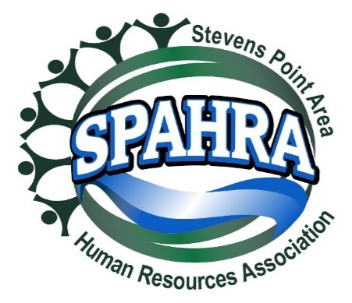 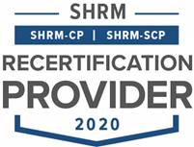

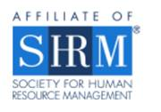

STEVENS POINT AREA

HUMAN RESOURCE ASSOCIATION

(SPAHRA)

EXECUTIVE COMMITTEE AND

COMMITTEE CHAIRS

MEETING

**DATE: Tuesday,** December 6, 2022 3:00 P.M.

**PLACE**: Zoom Call

Present: Allison Walsch, Anna Golackson-Timblin, Jerry Raikowski (non-voting member), Dean Dietrich, Marc Bouwer, Kelli Francis, Karla McGuigan

**Agenda**

1. **Call to Order: 3:03 p.m.**
2. **Approval of November 1, 2022 Minutes** Kelli (Allison) 6:0
3. **President’s Report (Marc)**
   * Board Election Results
     + Candidates
       - President-Elect - Open
       - Membership Chair – Vote Dean (Kelli) 6:0
         * Mandy Reeves – SPYMCA
         * [MReeves@SPYMCA.org](mailto:MReeves@SPYMCA.org)
         * 715-952-9362
       - Professional Development/Programming
         * Jerry Raikowski
         * [jerry.raikowski@remedystaff.com](mailto:jerry.raikowski@remedystaff.com)
         * 715-572-7771
   * Chapter Continuity Topics
     + Membership Pricing
       - All-Inclusive Price: $250, ($200 SHRM Member)
         * Agreed that at a lower # of meetings, this all-inclusive price is appropriate
         * National SHRM member rebate is ~$50
       - Per meeting Price:
         * Annual: $75, ($30 SHRM Member)
         * Per Meeting: $35.00 x7 = $245

Max: $320, ($275 SHRM Member)

* + - * Kelli (Allison) 6:0
      * Anna to research the Wild Apricot member options; Marc, Allison, and Anna to connect if cannot identify how best works.
      * What is the board member incentive?
        + Waive per meeting fee – no $35 if pay the lower annual
        + Board member not need to do the annual, all-inclusive
        + Dean (Allison) 6:0
      * 3 Breakfast + 3 Lunch Meetings w\Dec Social & virtual roundtables.
      * Comments
        + Requested subject matter & Professional Development Topics
        + Starting in February then every other month April, June, August, September, November, December
        + Start with Lunch (because familiar), then alternate
    - Board Meetings? (to fix attendance issues)
      * Change the day & time?
      * Every 2 months?
      * January (Feb member meeting), March (Apr), May (Jun), July (Aug, Sept), October (Nov, Dec)
      * Second week in January – 1/10, 3:00pm
    - Business Memberships/Sponsorships
      * 1 fee for HR Practitioners (HR Depts, HR Staff, Temp Service, recruiters/headhunters)
      * Larger fee for Vendor members (Law Firms, HRIS, background check & other vendors serving HR
      * *Look at this for the next meeting in January*

1. **President Elect (Karla)** 
   * **Shape Goals**
     + 5% Dual Membership Growth
     + 95% Dual Membership Retention
     + State Council Attendance (Marc/Karla)
     + VLBM Attendance (Marc/Karla)
   * **2022 SHAPE Initiatives:** 
     + **Membership**:
       - Create Quarterly promotion with orientation packet, free meeting coupon, program calendar flyer, and topical SPAHRA brochure (Kelli, Marc, Rebecca & Anna)
         * *The promotional packet is for prospective members – Focus on lapsed membership and smaller HR Organizations and HR development*
         * *Each Quarter will emphasize the unique value that SPAHRA and SHRM offers*
         * *Acquire Chamber of Commerce mailing lists*
     + **Community**:
       - Quarterly round table discussion with a Senior HR leader. (Ideas: Local HR Professionals, Selected SME’s from Industry, etc.) – monthly currently happening (Dean)
       - Quarterly Community Support Drives (Donations) (Karla)
         * Reformat communication materials (Marc, Kelli & Karla)
         * Provide SPAHRA donation matches

Quarterly Match Limit: $150.00

* + - * + Quarterly “Why it’s important to give to this organization” presentation (5 minutes) (Board Member/Org Representative)
        + Remind membership of the quarterly recipient at each monthly member meeting (Marc)
      * Host 2 Social Events outside of work (Maria**,** Anna & Allison)
  + Updates

1. **Immediate Past President (Maria)**
   * Updates
   * Last Year in Position
     + Absent
2. **Communications Chair Report (Kelli)**
   * Updates
     + Sent survey results 12/6/2022
     + Do a drawing at the Holiday social for a bigger prize; get all those names
     + Kelli will pull the member suggestions from survey to Jerry for program topics
3. **Treasurer’s Report (Allison)**

* Updates
  + $9,868 checking // 40,745 money market

1. **Professional Development/Programming (Terra)** 
   * Programming calendar 2023?
   * Updates
     + Absent
   * Jerry Onboarding?
     + Connected with Terra 12/6
2. **Membership Chair Report (Rebecca)**

* Updates
* Last Year in Position
* Mandy Reeves Onboarding?

1. **Secretary Report (Anna)**
   * Holiday Social?
   * Updates
     + Anna to send info
     + Gift certificates for outgoing board – Maria, Terra, Rebecca
     + Baskets for drawings ($200 total and then)
   * Anna template for notetaking, send to Karla and Marc
2. **Legal & Legislative Chair (Dean)**
   * Virtual roundtable updates
     + Wednesday, November 30, 2022
       - 7 attendees
       - Topic: Leave policies, Employee engagement efforts
   * Updates
     + There will be no Roundtable Discussion in December
     + No subject yet for January
3. **Other business?**
   * Marc ‘thank you’ to the board for the last year and offer to support
   * Send announcement of the rates and let them know that they can register
4. **Adjourn – 3:48 p.m. Marc (Kelli) 4:0**