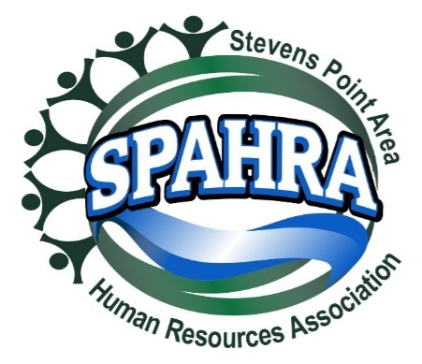 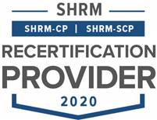

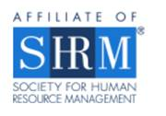

STEVENS POINT AREA

HUMAN RESOURCE ASSOCIATION

(SPAHRA)

EXECUTIVE COMMITTEE AND

COMMITTEE CHAIRS

MEETING

**DATE:** November 1, 2022 3:00 P.M.

**PLACE**: Zoom Call

Absent: Maria McKay, Allison Walsch, Terra Thompson, and Karla McGuigan

Jerry (Professional Dev – elect)

**Agenda**

1. **Call to Order: 3:01 p.m.**
2. **Approval of October 4, 2022 Minutes** Kelli (Rebecca)Approved 5:0
3. **President’s Report (Marc)**
   * October Board Election Results
     + Candidates
       - President-Elect - Open
       - Membership Chair - Open
       - Professional Development/Programming
         * Jerry Raikowski
         * [jerry.raikowski@remedystaff.com](mailto:jerry.raikowski@remedystaff.com)
       - Mention at the meeting. National and local SHRM made aware.
   * Chapter Continuity Topics
     + Membership Structure Survey
       - **Can we do both All-Inclusive (46.7%) & Per meeting Fees (53.3%)?**
         * Can we offer all-inclusive if pay up front or pay annual and then small meeting invite?
         * May need to look at the cost of the low annual fee – think it makes sense to offer both.
         * What do we want to budget per person per meeting, to make sure that getting a deal at that rate if prepay.
         * Deal through the annual pay.
         * Option 1 and 2, for all inclusive emembership and low annual membership with per meeting fee.

Dean (Kelli) for approval 5:0

Will need to get together with Allison to determine prices

Will socialize idea at next member meeting and then announce details via email later in November.

* + - * **3 Breakfast + 3 Lunch Meetings w\Dec Social & virtual roundtables. (46.7%)**
        + Seems reasonable; able to focus more on the programming.
        + Dean (Anna) for approval 5:0
      * Comments
        + Requested subject matter & Professional Development Topics
    - Board Meetings? (to fix attendance issues)
      * Change day & time
      * Every 2 months?
      * Parking lotted for next meeting
    - Business Memberships/Sponsorships
      * 1 fee for HR Practitioners (HR Depts, HR Staff, Temp Service, recruiters/headhunters)
      * Larger fee for Vendor members (Law Firms, HRIS, background check & other vendors serving HR
      * Parking lotted for next meeting

1. **President Elect (Karla)** 
   * **Shape Goals**
     + 5% Dual Membership Growth
     + 95% Dual Membership Retention
     + State Council Attendance (Marc/Karla)
     + VLBM Attendance (Marc/Karla)
   * **2022 SHAPE Initiatives:** 
     + **Membership**:
       - Create Quarterly promotion with orientation packet, free meeting coupon, program calendar flyer, and topical SPAHRA brochure (Kelli, Marc, Rebecca & Anna)
         * *The promotional packet is for prospective members – Focus on lapsed membership and smaller HR Organizations and HR development*
         * *Each Quarter will emphasize the unique value that SPAHRA and SHRM offers*
         * *Acquire Chamber of Commerce mailing lists*
     + **Community**:
       - Quarterly round table discussion with a Senior HR leader. (Ideas: Local HR Professionals, Selected SME’s from Industry, etc.) – monthly currently happening (Dean)
       - Quarterly Community Support Drives (Donations) (Karla)
         * Reformat communication materials (Marc, Kelli & Karla)
         * Provide SPAHRA donation matches

Quarterly Match Limit: $150.00

* + - * + Quarterly “Why it’s important to give to this organization” presentation (5 minutes) (Board Member/Org Representative)
        + Remind membership of the quarterly recipient at each monthly member meeting (Marc)
      * Host 2 Social Events outside of work (Maria**,** Anna & Allison)
  + Updates
    - None

1. **Immediate Past President (Maria)**
   * Updates
     + None
   * Last Year in Position
2. **Communications Chair Report (Kelli)**
   * Updates
     + None
3. **Treasurer’s Report (Allison)**

* Updates
  + Absent

1. **Professional Development/Programming (Terra)** 
   * Programming calendar 2023?
   * Updates
   * Jerry Onboarding?
2. **Membership Chair Report (Rebecca)**

* Updates
* Last Year in Position
  + Marc will pick this up for a few months in the beginning of 2023

1. **Secretary Report (Anna)**
   * Updates
     + None
2. **Legal & Legislative Chair (Dean)**
   * Virtual roundtable updates
     + Wednesday, October 19, 2022
       - 6 attendees
       - Topic: Childcare Issues and Leave Policies
       - Interesting conversation – discussed flex time. Broadly agreed that do flex time for employees and for production workers.
       - Choose this as a topic for one of the member meetings? It seems like continue to be a topic of interest.
     + Next Event Date: Wednesday, November 30, 2022 at 8:30 am
       - Topic?
   * Updates
     + Still dealing with NLRB moving further toward employee rights and recognition of employee rights. Nervous that members aren’t concerned about union organization.
     + Affirmative Action at the Supreme Court – that may impact HR and recruiting activities – unknown currently.
     + There will be no Roundtable Discussion in December
     + Need to consider topics for meetings and roundtables; can pull information from member comments in the survey.
3. Marc will contact Allison, contact Rebecca about membership, contact Terra about transitioning Jerry. Talk to Karla about transition.
4. For next meeting: ideas you have about fundraising to set up for Q1 of 2023.
5. **Other business?**
6. **Adjourn** 
   * Dean (Kelli) 5:0 – 3:30 p.m.