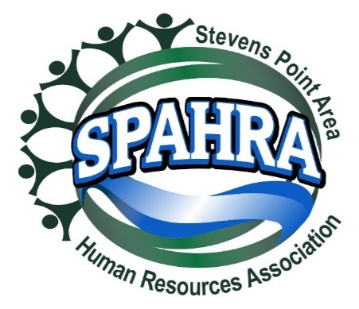 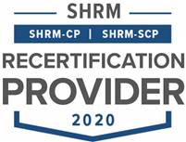



STEVENS POINT AREA

HUMAN RESOURCE ASSOCIATION

(SPAHRA)

EXECUTIVE COMMITTEE AND

COMMITTEE CHAIRS

MEETING

**DATE:** August 2, 2022 3:00 P.M.

**PLACE**: Zoom Call

**Agenda**

1. **Call to Order:**
2. **Approval of July 5, 2022 Minutes –** approval unanimously
3. **President’s Report (Marc)**
   * SPAHRA Secretary Job Description
     + Submission to SHRM?
     + Follow up with Terra regarding submission of the secretary job description and whether any feedback?
   * August Board Meeting
     + 3rd Quarter Donor Recipient – Project Fresh Start
       - Have we created a common messaging template for Donor Announcements? Marc to work with Kelli.
       - Add Project Fresh Start to the August invite?
       - Monetary donations take, also update with school supplies
       - Kelli + Rebecca announcement bring to the August 10th invite
       - Anna to update the website with Project Fresh Start
     + Open board positions? Plan to promote at the next meeting
       - President-Elect
         * Karla to reach out to some people she knows through her circles
       - Membership Chair
         * Anna to reach out to Mereta Walker (715-226-9100) about programming
       - Professional Development/Programming
         * Jerry Raikowski?
   * Leadership Conference
     + La Cross August 4 & 5
       - Marc Attending, anyone else?
         * No one else attending
4. **President Elect (Karla)** 
   * **Shape Goals**
     + 5% Dual Membership Growth
     + 95% Dual Membership Retention
     + State Council Attendance (Marc/Karla)
     + VLBM Attendance (Marc/Karla)
   * **2022 SHAPE Initiatives:** 
     + **Membership**:
       - Create Quarterly promotion with orientation packet, free meeting coupon, program calendar flyer, and topical SPAHRA brochure (Kelli, Marc, Rebecca & Anna)
         * *Promotional packet is for prospective members – Focus on lapsed membership and smaller HR Organizations and HR development*
         * *Each Quarter will emphasize the unique value that SPAHRA and SHRM offers*
         * *Acquire Chamber of Commerce mailing lists*
         * Planned for a 2023 start
     + **Community**:
       - Quarterly round table discussion with a Senior HR leader. (Ideas: Local HR Professionals, Selected SME’s from Industry, etc.) – monthly currently happening (Dean)
       - Quarterly Community Support Drives (Donations) (Karla)
         * Reformat communication materials (Marc, Kelli & Karla)
         * Provide SPAHRA donation matches

Quarterly Match Limit: $150.00

* + - * + Quarterly “Why it’s important to give to this organization” presentation (5 minutes) (Board Member/Org Representative)
        + Remind membership of the quarterly recipient at each monthly member meeting (Marc)
      * Host 2 Social Events outside of work – Virtual Happy Hour(Maria**,** Anna & Allison)
  + Updates

1. **Immediate Past President (Maria)**
   * Updates
   * None
2. **Communications Chair Report (Kelli)**
   * Updates
   * No updates
3. **Treasurer’s Report (Allison)** - absent

* Updates
* No updates

1. **Professional Development/Programming (Terra) -** absent
   * Programming calendar 2023?
   * Updates
2. **Membership Chair Report (Rebecca)**

* Updates
* No updates
* Last year in the position

1. **Secretary Report (Anna)**
   * Updates
   * Recap on July social
   * Board retreat in July to plan for fall? For next agenda
   * Quarterly meeting face-to-face? For next agenda
   * Survey out to the membership about childcare and significant others at events
     + Collect survey questions from board members, vote on what goes on the survey and then go out
   * Quick plug before the August meeting
   * September event location – Hancock? Schmeeckle Reserve space? Hotel Meade? Sky Club? The Idea Center?
2. **Legal & Legislative Chair (Dean)**
   * Virtual roundtable updates
     + Next event Date: Wednesday, August 24, 2022.
     + Topic: Recruiting and Retaining Employees
   * Updates
3. **Other business?**
4. **Adjourn – 3:43 p.m.**