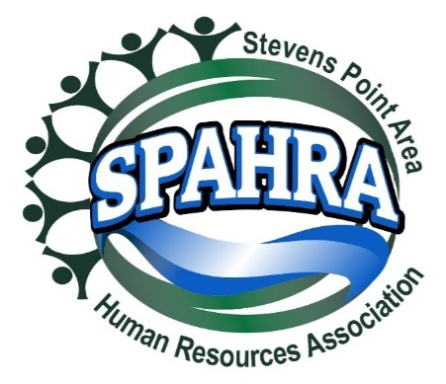 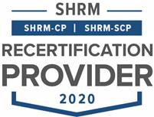

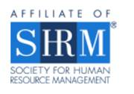

STEVENS POINT AREA

HUMAN RESOURCE ASSOCIATION

(SPAHRA)

EXECUTIVE COMMITTEE AND

COMMITTEE CHAIRS

MEETING

**DATE:** July 5, 2022 3:00 P.M.

**PLACE**: Zoom Call

Absent: Kelli Francis, Rebecca Kluck, Karla McGuigan, Maria McKay and Terra Thompson, Allison Walsch

Will send out items to vote and call a vote for online.

**Agenda**

1. **Call to Order: 3:05 PM – Anna GT, Dean D, and Marc B**
2. **Approval of June 7, 2022 Minutes – No Quorum**
3. **President’s Report (Marc)**
   * SPAHRA Secretary Job Description
     + Submission to SHRM?
     + Anna will send the job design after the meeting
     + Dean will send to Marc and Anna, then to SHRM
   * August Board Meeting
     + 3rd Quarter Donor Recipient – Project Fresh Start
       - $150 Match
       - Put together an email to notify the group. Marc to work with Kelli on that announcement.
         * Anna and Kelli can create common messaging templates
       - Anna will add Project Fresh Start to the August invite
     + Open board positions?
       - President Elect
       - Membership Chair
       - Legal & Legislative Chair – Maybe
         * Dean willing to continue
       - Next step is to notify membership with the upcoming positions and the job designs out.
   * Leadership Conference
     + La Crosse August 4 & 5
       - Marc Attending – Heartland Farms covering the cost, anyone else?
       - I believe the chapter covers the cost of lodging. No cost to attend.
4. **President Elect (Karla)** 
   * **Shape Goals**
     + 5% Dual Membership Growth
     + 95% Dual Membership Retention
     + State Council Attendance (Marc/Karla)
     + VLBM Attendance (Marc/Karla)
   * **2022 SHAPE Initiatives:** 
     + **Membership**:
       - Create Quarterly promotion with orientation packet, free meeting coupon, program calendar flyer, and topical SPAHRA brochure (Kelli, Marc, Rebecca & Anna)
         * *Promotional packet is for prospective members – Focus on lapsed membership and smaller HR Organizations and HR development*
         * *Each Quarter will emphasize the unique value that SPAHRA and SHRM offers*
         * *Acquire Chamber of Commerce mailing lists*
     + **Community**:
       - Quarterly round table discussion with a Senior HR leader. (Ideas: Local HR Professionals, Selected SME’s from Industry, etc.) – monthly currently happening (Dean)
       - Quarterly Community Support Drives (Donations) (Karla)
         * Reformat communication materials (Marc, Kelli & Karla)
         * Provide SPAHRA donation matches

Quarterly Match Limit: $150.00

* + - * + Quarterly “Why it’s important to give to this organization” presentation (5 minutes) (Board Member/Org Representative)
        + Remind membership of the quarterly recipient at each monthly member meeting (Marc)
      * Host 2 Social Events outside of work – Virtual Happy Hour(Maria**,** Anna & Allison)
  + Updates

1. **Immediate Past President (Maria)**
   * Updates
2. **Communications Chair Report (Kelli)**
   * Updates
   * Gift Cards – How Much?
3. **Treasurer’s Report (Allison)**

* Updates
* Discussion and Motion to Approve using money market funds for social events.
  + This discuss and motion is still needed. Maria and/or Heather.

1. **Professional Development/Programming (Terra)** 
   * Programming calendar 2023?
   * Updates
2. **Membership Chair Report (Rebecca)**

* Updates

1. **Secretary Report (Anna)**
   * Updates
   * July Social Event Announcement & Registration?
     + Anticipated to go out by 7/8
2. **Legal & Legislative Chair (Dean)**
   * Virtual roundtable updates – see Legal Update memo
     + Next event Date: Wednesday July 26, 2022?
     + Topic: Recruiting and Retaining Employees
   * Updates AKA Things to Watch For
     + Reversal of Roe V. Wade, employers possible expanding resources to folks in need of repro healthcare
     + If employer agrees to time off, may be subject to penalties, because complicit.
       - E.g., Tier 1 services in Heartland’s benefits. Not for single condition but could be applicable to this situation.
     + Supreme Court ruling on school district employee praying after football game on employer property.
       - May have impact for employers moving forward.
   * Wednesday, July 27th next roundtable
3. **Other business?**
4. **Adjourn – 3:34 p.m.**