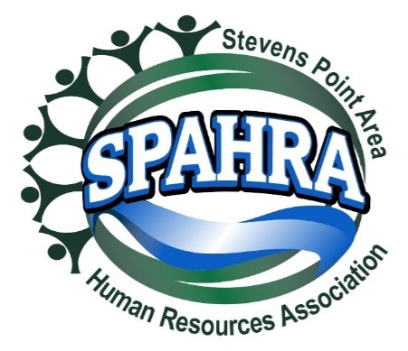 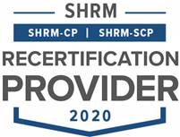



STEVENS POINT AREA

HUMAN RESOURCE ASSOCIATION

(SPAHRA)

EXECUTIVE COMMITTEE AND

COMMITTEE CHAIRS

MEETING

**DATE:** April 5, 2022

**PLACE**: Zoom Call

**Agenda**

1. **Call to Order: 3:02 PM (Anna, Terra, Dean, Marc, Kelli, Karla, and Maria)**
2. **Approval of March 2022 Minutes** 
   * Send out just after the meeting so everyone has their to-dos?
   * Dean (Terra) – 4:0 approval
3. **President’s Report (Marc)**
   * May Meeting Venue?
     + Sentry or Stevens Point Area Country Club?
     + Need to schedule the next meeting – move to the SPCC for May
   * Quarterly Donor Drive?
     + Recipient?
       - Marc to connect with Allison and/or Maria about how this has happened in the past – who was last recipient, get a list, and vote via email in time for April meeting.
       - The Board decided what area focus on, did focus on school, providing resources or $ to food pantries, etc. Individuals would volunteer an organization that knew.
       - Add to SPAHRA website to make donations – Anna may be able to assist with this.
       - In the past, group effort. Samantha drove that and then Kelli would send out the communications.
       - Marc will round up childcare focus and what gather from Maria and Allison for next steps and then likely vote on recipient. Confirm with Allison what a match could be.
   * Updates
4. **President Elect (Karla)** 
   * **Shape Goals**
     + 5% Dual Membership Growth
     + 95% Dual Membership Retention
     + State Council Attendance (Marc/Karla)
     + VLBM Attendance (Marc/Karla)
   * **2022 SHAPE Initiatives:** 
     + **Membership**:
       - Create Quarterly promotion with orientation packet, free meeting coupon, program calendar flyer, and topical SPAHRA brochure (Kelli, Marc, Rebecca & Anna)
         * *Promotional packet is for prospective members – Focus on lapsed membership and smaller HR Organizations and HR development*
         * *Each Quarter will emphasize the unique value that SPAHRA and SHRM offers*
         * *Acquire Chamber of Commerce mailing lists*
       - *Marc and Karla to get together to discuss pamphlets to send out quarterly.*
     + **Community**:
       - Quarterly round table discussion with a Senior HR leader. (Ideas: Local HR Professionals, Selected SME’s from Industry, etc.) – monthly currently happening (Dean)
       - Quarterly Community Support Drives (Donations) (Karla)
         * Reformat communication materials (Marc, Kelli & Karla)
         * Provide SPAHRA donation matches

Quarterly Match Limit: $

* + - * + Quarterly “Why it’s important to give to this organization” presentation (5 minutes) (Board Member/Org Representative)
        + Remind membership of the quarterly recipient at each monthly member meeting (Marc)
      * Host 2 Social Events outside of work – Virtual Happy Hour(Maria**,** Anna & Allison)
        + July Meeting – started working on
        + December social event as done in previous years
  + Updates

1. **Immediate Past President (Maria)**
   * Updates
     + No updates
2. **Communications Chair Report (Kelli)**
   * Updates
     + No updates
     + Childcare meeting held between Worzalla and Kindercare with a few questions about if recording. Redirect to the representative for that event.
     + Push the in-person meetings in social media, tagging Todd so that he can share there. Bump up social media presence.
3. **Treasurer’s Report (Allison)**

* Form 990N needs to be completed
* USPS PO Box Renewal
* Updates
  + Allison will update us via email on these topics.

1. **Professional Development/Programming (Terra)** 
   * Programming calendar 2022 – updates
   * Updates
     + Still working on half-day for June. 2022 planned. 2023 getting there for the plan.
     + Marc will forward a potential speaker to Terra to connect on the calendar for next year.
2. **Membership Chair Report (Rebecca)**

* SPAHRA membership audit?
* Updates
  + Did do a membership audit roster.
  + Receiving CFS payment, we received $00 int otal payment for fourth quarter of 2021. Allison also received; Marc will follow up with Allison.

1. **Secretary Report (Anna)**
   * Summer Social Event Planning (Anna/Allison/Terra)
   * Updates
     + Targeting a Central Waters July 21 for our social event.
     + Anna met with Create Portage County to discuss structured networking at event.
     + Anna and Allison to discuss and bring a report back for the May meeting.
2. **Legal & Legislative Chair (Dean)**
   * Virtual roundtable updates – see Legal Update memo
     + Wednesday, April 27th next event. Looking for volunteers to discuss Teamwork and Team Building activities.
   * Updates
     + Good discussion and turnout at last roundtable.
     + One more month of retention of employees. Talk about teamwork and team building – looking for a volunteer to develop.
     + Suggest HR Director from Renaissance Learning to be interviewed.
     + WI Supreme Court rendered decision on arrest and conviction history. May have opened the door for employers to apply the standard of substantially related comparing the circumstances of the conviction to circumstances of the job.
     + Dean does not believe the applicability law changes and way interpret the law very much. Others feel that it opens for broader interpretation. Suggests that could look at the circumstances of a conviction to determine whether substantially relates to the job that the person is or would perform.
       - Court objected to way Equal Rights Division to that level of specificity.
       - Case that approximately six years old, custodian worked with boilers for heating the facility. After hired and had working, completed CBC, and uncovered a conviction for throwing boiling water on a minor. That was not substantially related.
     + Amazon Union election comprised of former and current employees that not affiliated with AFL-CIO or other national organizations. Does signal or potentially signals a growth in the whole areas of union organizing and activity. National focus right now is very on union organizing activities.
       - Not much activity in central Wisconsin but is something to watch.
3. **Other business?**
   * No other business
4. **Adjourn** 
   * **Dean (Maria) 3:37 p.m.**