 | 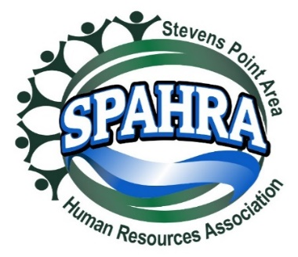
STEVENS POINT AREA HUMAN RESOURCE ASSOCIATION (SPAHRA)
EXECUTIVE COMMITTEE AND COMMITTEE CHAIRS MEETING AGENDA |  | Meeting Date: | 3/7/2023
 |  | Location: | Zoom
Call to Order: | 3:08 PM | Adjourn: | 3:39 PM
Attendees: | Karla McGuigan, Dana Williams, Anna Golackson-Timblin, Kelli Francis, Allison Walsch, Jerry Raikowski, Mandy Reeves, Dean Dietrich  Absent: Marc Bouwer, Kelli Francis, and Jerry Raikowski
Agenda Items |  | Discussion/Notes |  | Votes
- Approval of 01/10/2023 minutes |  | Move to approve: Dean (Karla) |  | 6:0
- President’s Report (Karla)  - Board Election Results  - Chapter Continuity Topics  - SHAPE Goals |  | - Welcome Dana: Dana introduction  - Karla and Dana will connect outside our meetings on president-elect role  - Karla and Marc will meet next week (3/14 at 9:00a) regarding the SHAPE goals  - Meeting schedule is working okay  - Marc will work on the website and promotional materials
- President Elect (Dana)  - Shape Goals  - 2022 Shape Initiatives  - Updates |  | Karla included the 2022 shape goals as a frame of reference
- Immediate Past President (Marc)  - SPAHRA Website Refresh  - Updates |  | N/A
- Communications Chair Report (Kelli)  - Update |  | Kelli provided Member Survey from Feb event; relayed to group by Anna, will be sent with today’s notes.
- Treasurer’s Report (Allison)  - Updates |  | Allison will send account #s after the meeting
- Professional Development/Programming (jerry)  - Updates |  | - Karla outreach regarding the April event – food and room set up per Feb event feedback
- Membership Chair Report (Mandy)  - Updates |  | - Karla sent an email from SHRM about an annual membership report. Never heard more from her about that.  - Outreach to Marc about next steps on submitting that report.  - Mandy attend the Tuesday, 3/14 meeting. Karla will send the original email with the attachments.
- Secretary Report (Anna)  - Holiday Social  - Updates |  | - Holiday social was awesome! Smaller group but more engaged.  - Looking at the use of the Google drive as a location to save things and update. Anna will talk to Kelli about this option.
- Legal & Legislative Chair (Dean)  - Virtual Roundtable  - February Roundtable overview  - Updates |  | - Summaries of the last two roundtables sent. Roundtable was same day as the snow day – great attendance and continued discussion of PTO and COVID. Follow-up materials from this meeting will go out with March program notice. Continued discussion of PTO  - Excitement in the employment law from NLRB, provisions in severance agreement that prohibit employment in conversation about the company (i.e., non-disparagement, limit the confidentiality of agreement) declared illegal under the NLRA. Topic for the roundtable. Don’t see a lot of NLRB cases, not sure that a major concern to members but is being discussed in employment law.  - Previously, reported FTC outlaw provisions in contracts or non-compete agreements with employees. Going through the steps. Not sure if a major concern for our members.  - Dean looking for folks to interview as a part of the process.
- Other business |  | Mandy: A local insurance rep is interested in joining SPAHRA. Does someone have to be an HR Professional to join? No, but given the lack of obvious professional overlap between current role and SPAHRA, rep should submit interest to be reviewed by the Board of Directors.  If the interest is in using our membership list for sales, would be appropriate to invite to an upcoming member event to pitch.  Motion to adjourn Karla (Mandy) |  | 6:0

