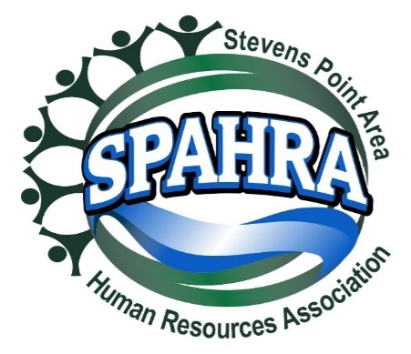 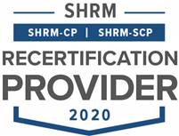



STEVENS POINT AREA

HUMAN RESOURCE ASSOCIATION

(SPAHRA)

EXECUTIVE COMMITTEE AND

COMMITTEE CHAIRS

MEETING

**DATE:** February 1, 2022

**PLACE**: Zoom Call

**Agenda**

1. Call to Order: 3:33pm
2. Approval of January 2022 Minutes
   * Approval of minutes Maria (Dean)
3. President’s Report (Marc)
   * Two gift cards for Ruby’s, do we have survey participants who earned this?
     + 13 respondents, 7 and 11
     + Marc will be sent back
   * SPAHRA Job Descriptions
     + Remain as they are
     + Marc will reach out to contact each one of us if there is something that you need help with over the next month.
   * Microsoft Teams Invitations?
     + Spent some time on the files issue – reach out through Teams website for chats or calls.
   * Updates
     + 2022 SHAPE Year End Report has been filed
       - Filed last week with numbers in Karla’s section included Goals.
       - Everyone should review and
     + Membership Fees (Nora Boomer)
       - We spent only 36.4% of chapter revenue in 2021
       - (Allison) Fee was established so that assured revenue even if online. Recoup some money for years that lost money
       - (Allison) Uptick in attendance at holiday social, maybe we could do a summer social event e.g., member appreciation
       - (Marc) does this cover the cost of meetings in a normal year? (Allison) would be a low cost especially including roundtable. Would be losing money that way.
       - (Marc) two events in Feb and March no cost because no meal. In lieu of refund or adjusted rate, would absorb some of the cost of the for-charge meeting.
       - (Maria) could match some funds for quarterly drives.
       - (Allison) volunteer to look into this programming. Partner with Terra and Marc on that as well.
       - (Marc) Karla, Allison, and Marc to discuss quarterly match campaign.
       - Dean(Maria) move to hold July event.
       - Vote 7:0:0 for July social event
4. President Elect (Karla)
   * Shape Goals
     + 5% Dual Membership Growth (3)
     + 95% Dual Membership Retention (57)
     + Membership Director Dual Member
     + Certification Director is a Dual Member & Certified
       - This falls under the Professional Development Chair (Terra); Marc reach out to confirm
       - This requirement is likely new
     + State Council Attendance (Marc/Karla)
     + VLBM Attendance (Marc/Karla)
     + Foundation Donor drive & donation
     + Volunteer Leadership Campaign
     + SHRM Certification Promotion
       - Push in the next month or two but need an instructor. If interested, reach out to Marc.
   * Proposed SHAPE Initiatives (See Attached)
     + Comments?
       - (Dean) more discussion regarding roundtable activity. Report in Dean’s section. Monthly v. quarterly roundtable is a lot of programming. Need to determine how to get more people to attend. Willing to elevate to guest speaker.
       - (Marc) willing to be speaker
       - (Allison) add to new brainstorming meeting in March
   * Updates
5. Immediate Past President (Maria)
   * Updates
   * No updates
6. Communications Chair Report (Kelli)
   * Updates
   * Sharing HR job posting – request from non-member.
   * Discussion:
     + What provides our membership the most value? Because specific to the field, is helpful.
     + The verbiage to the non-member asking for internally is ask for membership after that – maybe a request for membership from the member director role.
   * The two people that drawn for the gift card are both lapsed members – Nora Boomer and Justin Rueb.
     + Justin likely to renew
     + Nora likely to renew
     + Okay, given likelihood of renewal.
7. Treasurer’s Report (Allison)

* Updates
* Checking account is $12,187
* Money market is $40,732

1. Professional Development/Programming (Terra)
   * Programming calendar 2022 – updates
   * Updates
   * Not present
2. Membership Chair Report (Rebecca)

* Membership drive update
* Use of chamber lists, LinkedIn, and other platforms to drive membership
* Updates

1. Secretary Report (Anna)
   * Updates
     + All events that have details are in Wild Apricot
     + Have many questions
       - Who should be the SPAHRA contact for events?
       - Should we send the roundtables through Wild Apricot?
       - Should Zoom information go out in confirmation email or in even notice? Determined in confirmation
     + (Marc) Let’s meet to discuss your questions.
2. Legal & Legislative Chair (Dean)
   * Virtual roundtable updates – see Legal Update memo
     + See document sent 1/31/22
     + Willing to update format and work together on this. Maybe a volunteer for interview.
     + If any board members have any opinions on this topic: what needs to be discussed next how do, we retain employees? What are best practices to retain employees? (a) is this a good topic? (b) will people share?
     + Discussion: generally, like the topic. Focus on implementation.
     + (Dean) will put together invite for the last Wednesday in February.
   * Updates
     + NLRB changing direction – seeing a tightening of independent contractor rules. Is this something we want to pursue further in a roundtable?
     + Discussion: valuable if can be distilled and relevant for members
3. Other business
   * None
4. Adjourn
   * Allison (Dean). 4:24pm